CMSME 2019 Registration Form
2019 International Joint Conference on Materials Science and Mechanical Engineering
Jan.18-20 | Phuket, Thailand | www.cmsme.net
NOTE: Please send the required documents: 1. final paper(doc&pdf), 2. filled registration form, 3. Payment Voucher to cmsme@iased.org to finish the registration. (Mail Subject: Paper ID+Registration).
- ATTENDEE INFORMATION
*Full Name:
*Position√: Prof. □  Assoc. Prof. □  Asst. Prof. □ Dr. □  Mr. □  Ms. □
*Affiliation & Country:
*Email: *Mobile:
Emergency Contact(Name&Mobile):
Address& Zip Code (for post use):
Catering Service(Jan.19)√: Lunch □ Dinner □
Special dietary√: Diabetic □ Vegetarian □ Muslim □ Other □ (please specify: )
Special requirements:

1-inch-Photo here
- PAPER INFORMATION
*Paper ID: *Paper Pages: *Additional Page:
*Paper Tile:
*Authors:
*Presentation Terms√: Oral □ Poster □ Remote Video □ Video □
Student ID No.(student only):
IASED Member No.(member only):
* Receipt Issued to:
- REGISTRATION FEE(by US dollar)
Category | Early  (Until Nov. 23) | Regular  (Until Jan. 11) | On-site  (After Jan. 11) | Your Choice
IASED Member | USD 400 | USD 470 | USD 550
Nonmember | USD 430 | USD 500 | USD 570
Student | USD 375 | USD 425 | USD 475
One-day Program | USD 300 | USD 320 | USD 350
Special Session | Free | Free | Free

Extra Item | Cost | Your Choice
Extra Page / Per page | USD 70
Extra Paper Upload | USD 300
Extra Banquet Ticket | USD 50
One Day Tour | TBD
Total Conference Fees
*Notice
*One regular paper is within 6 pages, including all figures, tables, and references, extra pages need to pay Additional page fee.extra page will be charged, not exceed 10 pages.
*All the papers will be published on-line.
- PAYMENT INFORMATION
Online Payment linkage
http://meeting.yizhifubj.com.cn/web/main.action?meetingId=351
* VISA /Master can valid. No handling fees, please calculate the amount and pay.
Please fill your E-mail address used for payment and Confirmation Number you received after paying.
E-mail: | Confirmation Number:

- IASED MEMBER APPLICATION
Join IASED now to quality for member registration rates. Please compile and return the Membership Form along with your CV to membership@iased.org. Your application will be processed in 5 working days.
- OTHER
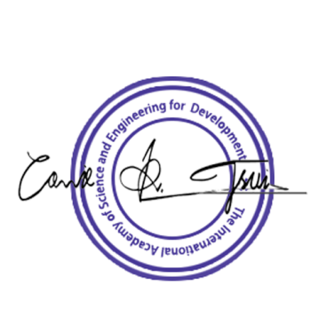
Finally, we suggest you write down a biographical sketch here, for use of making introductions by Session Chair before your presentation gets started.
20-120 Words(1-6.5 lines)

CMSME 2019 Conference Committee
Phuket, Thailand

